PROJECT DOCUMENT

Amazon Sales Report Project

PREPARED BY

ALLWIN JEYARAJ

Table Of Content:

* Introduction
* Project Overview
* Data Overview
* Data Structure
* Data Cleaning
* Data Analysis
* Visualization
* Tools and Technology
* References

INTRODUCTION:

The Amazon Sales Report Analytics project aims to provide a comprehensive analysis of sales data from Amazon's marketplace. By examining key metrics such as geographical distribution, product category performance, and sales trends over time, the project identifies critical insights to optimize inventory, enhance marketing strategies, and drive business growth. This report serves as a strategic tool for understanding consumer behaviour, improving decision-making, and maximizing sales performance on Amazon.

PROJECT OVERVIEW:

The Amazon Sales Report Analytics project focuses on analysing sales data to uncover trends, patterns, and insights that drive business growth. The project evaluates sales performance across different regions, product categories, and time periods, providing actionable recommendations to optimize inventory, refine marketing strategies, and enhance customer engagement. By leveraging data-driven insights, the project aims to help businesses maximize their sales potential on Amazon's platform.

TARGET AUDIENCE:

The target audience for an Amazon Sales Report includes business owners, sales and marketing teams, inventory managers, financial analysts, and e-commerce managers who need insights to drive sales performance, optimize inventory, and refine marketing strategies.

DATA OVERVIEW:

Data Source:

The data sources for an Amazon Sales Report include 12889 records with all necessary dataset such as date of the product ordered, category, shipment details and the dataset is derived from the company itself.

Data Structure:

The structure of the dataset, including the main fields such as

* Order ID
* Status
* Category
* Size
* Courier Status
* Amount
* Ship-City
* Ship-Postal-Code

DATA CLEANING:

The Amazon Dataset has been Cleaned by removing errors, duplicate and irrelevant information as well as formatting the rows and columns.

DATA ANALYSIS:

Geographical Analysis:

The geographical analysis for an Amazon Sales Report examines sales distribution across different regions, such as states and cities. This analysis identifies key markets, highlights top-performing areas, and uncovers regional sales trends. It helps in targeting marketing efforts, optimizing inventory allocation, and tailoring product offerings to specific geographic locations to maximize sales potential.

Customer Behaviour Analysis:

Customer behaviour analysis for an Amazon Sales Report examines purchase patterns, repeat customer rates, and product preferences. This analysis helps identify loyal customers, understand buying habits, and tailor marketing strategies to boost customer retention and increase sales.

Sales Trend Analysis:

Sales trends analysis for an Amazon Sales Report involves examining sales data over time to identify patterns, peak periods, and seasonal trends. This analysis helps in forecasting demand, planning inventory, and optimizing promotional strategies to align with high-sales periods, ultimately driving better sales performance.

VISUALIZATION:

* Chart and Graph, include relevant charts and graphs created during the analysis, such as

1. Total product ordered date wise using pivot table
2. Total Product categorization based on sizes
3. Shipment Details of product state wise
4. Total amount in a day& Highest amount collected in a day
5. Visual representation of product sold by size and quantity
6. Total sales per states

Tools and Technologies:

**Software Used:**

* List the tools and software used for the analysis, such as:

Excel (for Pivot Tables, charts, and maps)

References:

* <https://www.geeksforgeeks.org/pivot-tables-in-excel/>
* <https://www.youtube.com/watch?v=MnPVfxOTvvk>

Total product ordered date wise using pivot table

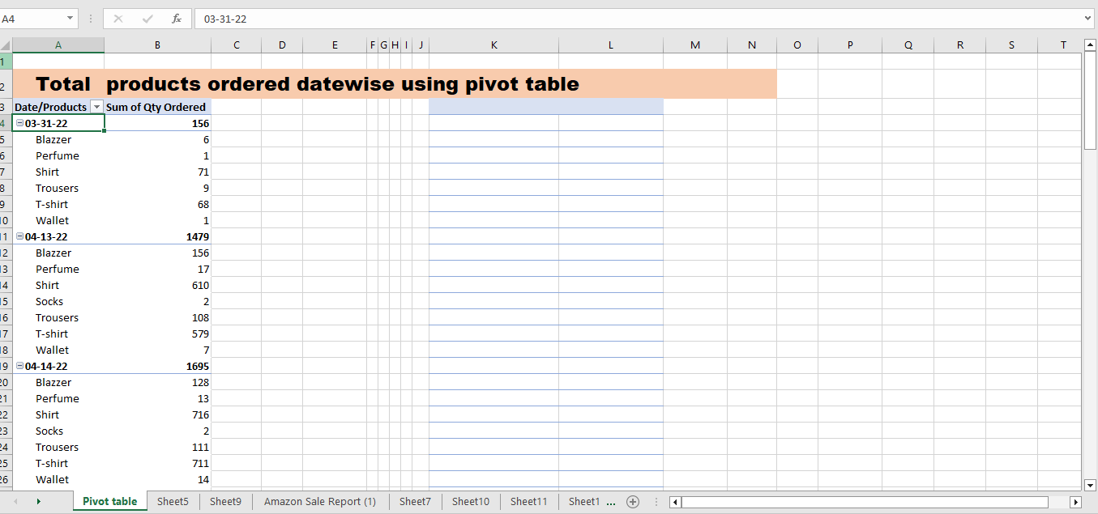

Total Product categorization based on sizes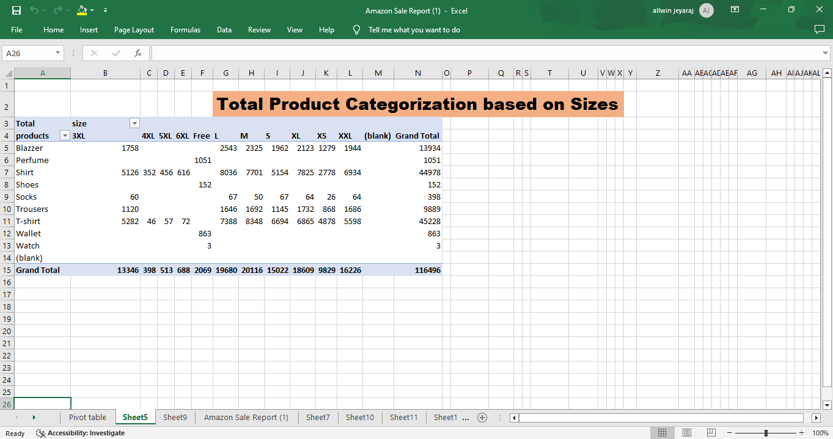

Shipment Details of product state wise

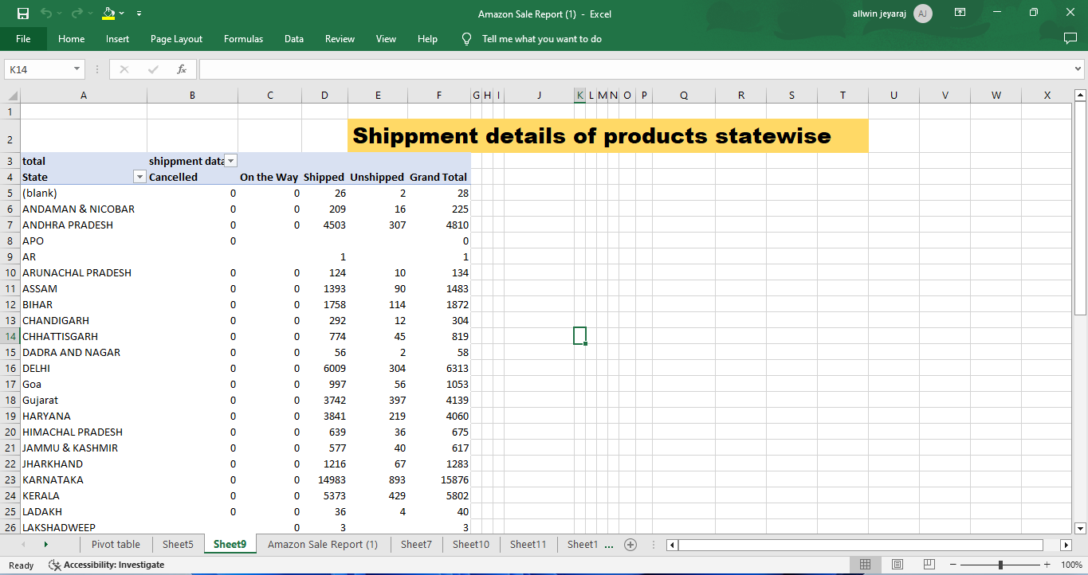

Total amount in a day& Highest amount collected in a day

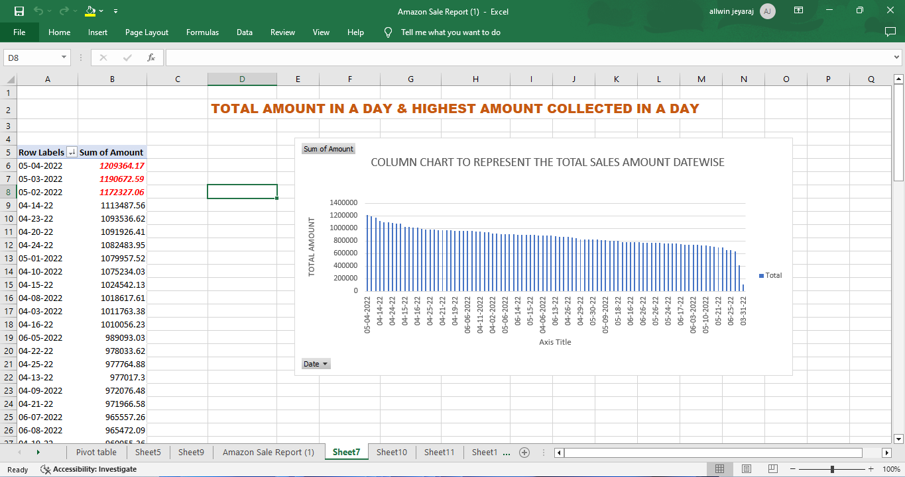

Visual representation of product sold by size and quantity

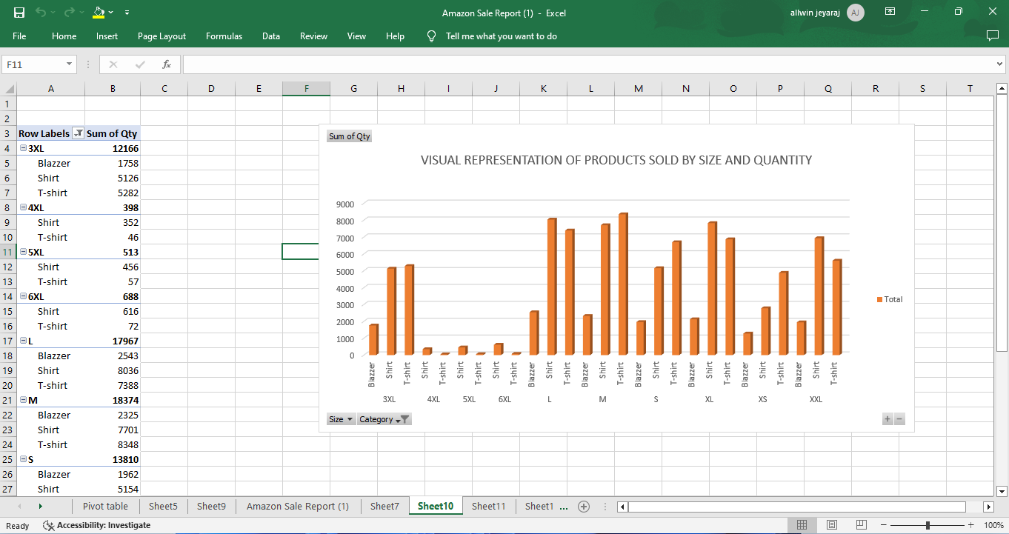

Total sales per states

